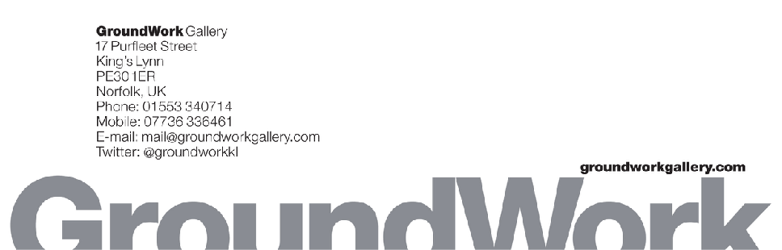
GroundWork Gallery ‘Ground Up’ Residency application form
‘Ground Up’ is the title of GroundWork Gallery’s fourth annual artist residency and summer exhibition programme for 2024. Continuing our focus on issues surrounding the topic of Extraction this year we are asking artists to consider;

- What is removed from the earth via extraction, excavation, dredging, mining, foraging, etc. and why?
- The effects of extraction on any ecological system.
- The best means to draw attention to extraction.

Considering our location in Norfolk, we prefer artists to make use of the experience in the local area in their work, but it is not an essential requirement.
General notes
- Complete the application form and include 4 supporting images at the end of the document.
- Save the document as a pdf and return to mail@groundworkgallery.com with the heading Residency Application
- Please only use this form and keep within stated word limits, no other attachments will be considered.
- Return the completed application by 24.00 Tuesday 2 April 2024

Residency information

• There are 3 residency locations: The GroundWork Gallery, King’s Lynn; The Grange Projects, Great Cressingham, and Broomhill, Reepham. Full information on each site is in the guidance on-line. As part of our assessment, we reserve the right to make the final decision about location, but we will try to accommodate your wishes if you have a strong preference.

• Each residency consists of two phases: a mandatory research and exploration week for all participants w/c 22nd July and a further 1 or 2 weeks (depending on the site and the artist) between 16 July and 25 August 2024.

• The residencies are offered on a no-fee basis. However, each host offers hospitality in the form of free accommodation, meals or ingredients to make meals (contribution to costs will be appreciated), a rich programme of field and research trips, advice and help with making further contacts, shared local transport, peer review among a residency community.

- All participating artists will be considered for the group exhibition Ground Up, at GroundWork Gallery from October to December 2024.

mail@groundworkgallery.com

Applicant information
Name
Address

Email
Telephone
Website
Where did you see/hear about the residency?

1. Education & training – start with the most recent
Institution
Date from / to

Certification
Date

2. Exhibitions – summary of most recent and / or relevant
Gallery or site
Date from / to
Comments

3. Residency
a) Why do you think you are the right person for this residency?
300 word limit

b) What do you want to achieve during the residency?
300 word limit

Which residency site would you prefer? Tick all if you don’t mind which. Please note hosts reserve the right to recommend the final choice
GroundWork Gallery, King's Lynn
The Grange Projects, Great Cressingham
Broomhill, Reepham

4 Dates: Please state your preferred dates,
NB Please note, 22 - 28 July is the compulsory research week which you must check

15 - 21 July

22 - 28 July

29 July - 4 August

5 - 11 August

12 - 18 August

19 - 25 August

5. Images of existing work
Please send this together with no more than 4 images giving us an idea of your work.

Please send the form as a PDF by e mail to mail@groundworkgallery.com by 24.00 on 2 April 2024, with the heading Residency Application

